Entity Relationship Model Practice Solutions
- A university maintains information about students. Each student has a student ID, name, date of birth, email address, and major. The university stores thousands of student records.
  - Identify the entity
    - Student
  - Provide three examples of entity instances
    - Student ID 10001: John Smith
    - Student ID 10002: Maria Lopez
    - Student ID 10003: David Chen
  - Identify five attributes of the entity
    - StudentID
    - StudentName
    - DateofBirth
    - EmailAddress
    - Major
  - Explain the difference between an entity and an entity instance
    - An entity represents a category of objects being modeled (Student).
    - An entity instance represents one specific occurrence of that entity (John Smith with StudentID 10001).
- A customer database stores the following attributes:
CustomerID
CustomerName
CustomerAddress
DateofBirth
Age
AccountBalance
PhoneNumber
Classify each attribute as one of the following and explain your rationale
  - Atomic or Composite
  - Stored or Derived

Attribute | Classification | Rationale
CustomerID | Atomic, Stored | A single value used to identify a customer
CustomerName | Atomic or Composite (dependent on company type), Stored | Can be stored as one value or divided into first/last name
CustomerAddress | Composite, Stored | Contains street, city, province, Postal code
DateofBirth | Atomic, Stored | Stored directly in the database
Age | Atomic, Derived | Calculated from DateofBirth
AccountBalance | Atomic, Stored/Derived | Maintained directly as a database value depending on other data
PhoneNumber | Atomic, Stored | Treated as a single data element
- Analyze the following relationships and identify whether each relationship is One-to-One, One-to-Many, or Many-to-Many.
  - A customer can place many orders
    - One-to-Many
  - A student can enroll in many courses
    - Many-to-Many
  - Each employee has one company parking permit
    - One-to-One
  - Each department has many employees
    - One-to-Many
- A university bookstore tracks textbooks, authors, publishers, and sales transactions.
  - Identify four possible entities
    - Textbook
    - Author
    - Publisher
    - Sale
  - Explain why each item qualifies as an entity
    - Textbook: A textbook qualifies as an entity because the bookstore needs to store information about individual textbooks, such as title, ISBN, price, and edition
    - Author: An author qualifies as an entity because authors are distinct people about whom the bookstore may store information, such as name and contact or biographical details
    - Publisher: A publisher qualifies as an entity because publishers are separate organizations associated with textbooks and may have their own identifying information, such as publisher name and address
    - Sale: A sale qualifies as an entity because each sales transaction represents a separate business event that the bookstore needs to record, such as sale date, total amount, and payment method
  - Identify one possible instance of each entity
    - Textbook: Database Systems
    - Author: Carlos Connolly
    - Publisher: Pearson
    - Sale: #10542 completed on August 14, 2026
- A medical clinic stores information about patients. Determine whether each item is an entity or an attribute and explain your rationale.
  - Patient
    - Entity: represents people whose information is stored
  - PatientName
    - Attribute, describes a patient
  - InsuranceCompany
    - Entity: may require separate information storage
  - Appointment
    - Entity: represents scheduled visits
  - PhoneNumber
    - Attribute: describes a patient
  - Physician
    - Entity: represents healthcare providers
- Analyze the following relationships and identify the relationship type, the parent entity, the child entity, and explain whether an associative entity is required.
  - A person has one passport. A passport belongs to one person.
    - Relationship Type: One-to-One
    - Parent Entity: Person
    - Child Entity: Passport
    - Associative Entity Required: No
    - Explanation: Each Person is related to only one Passport, and each Passport is related to only one Person. A foreign key can be placed in the Passport entity to reference the Person entity. An associative entity is not required because there is no many-to-many relationship.
  - A department employs many employees. Each employee works for one department.
    - Relationship Type: One-to-Many
    - Parent Entity: Department
    - Child Entity: Employee
    - Associative Entity Required: No
    - Explanation: One Department can employ many Employees, while each Employee belongs to only one Department. The primary key from Department would be stored as a foreign key in Employee. An associative entity is not required.
  - A student can enroll in many courses. Each course can contain many students.
    - Relationship Type: Many-to-Many
    - Parent Entities: Student and Course
    - Child Entity: The associative entity, such as Enrollment
    - Associative Entity Required: Yes
    - Explanation: A Student can be related to many Courses, and a Course can be related to many Students. A many-to-many relationship cannot normally be implemented directly in a relational database. An associative entity such as Enrollment is required. Enrollment would contain StudentID and CourseID as foreign keys and could be used together as a composite primary key.
  - A vehicle has one assigned license plate. A license plate belongs to one vehicle.
    - Relationship Type: One-to-One
    - Parent Entity: Vehicle
    - Child Entity: LicensePlate
    - Associative Entity Required: No
    - Explanation: Each Vehicle is assigned one LicensePlate, and each LicensePlate belongs to one Vehicle. A foreign key can be placed in the LicensePlate entity to reference Vehicle. An associative entity is not required because the relationship is one-to-one.
- A company stores employee information
EmployeeNumber
SocialInsuranceNumber
EmployeeName
HireDate
  - Select the best primary key
    - EmployeeNumber is unique, stable, and created specifically to identify employees
  - Explain why the other attributes are not ideal primary keys
    - SocialInsuranceNumber may be unique but is sensitive personal information
    - EmployeeName is not guaranteed to be unique
    - HireDate can contain duplicate values
- Analyze the following business rules and identify whether each relationship is One-to-One, One-to-Many, or Many-to-Many.
  - Each vehicle has one VIN number
    - One-to-One
  - A customer can submit multiple support tickets
    - One-to-Many
  - A movie can have many actors, and an actor can appear in many movies
    - Many-to-Many
- A music streaming service stores artists and songs with the following business rules: an artist can create many songs, a song can have many artists, each song must track the artist's contribution.
  - Identify the many-to-many relationship
    - The many-to-many relationship is between Artist and Song, an Artist can create many Songs, and a Song can be created by many Artists
  - Create an associative entity to resolve the relationship
    - Artist is One-to-Many to ArtistSong
    - Song is One-to-Many to ArtistSong
  - Identify the primary key of the associative entity
    - The primary key of ArtistSong should be a composite primary key consisting of ArtistID and SongID, this ensures that the same Artist and Song combination cannot be entered more than once
  - Identify all foreign keys.
    - ArtistSong.ArtistID is a foreign key that references Artist.ArtistID
    - ArtistSong.SongID is a foreign key that references Song.SongID
- A restaurant tracks customer reservations, a reservation may use one or more dining tables, and a dining table may be used for many reservations over time. Given the ERD, answer the corresponding questions:
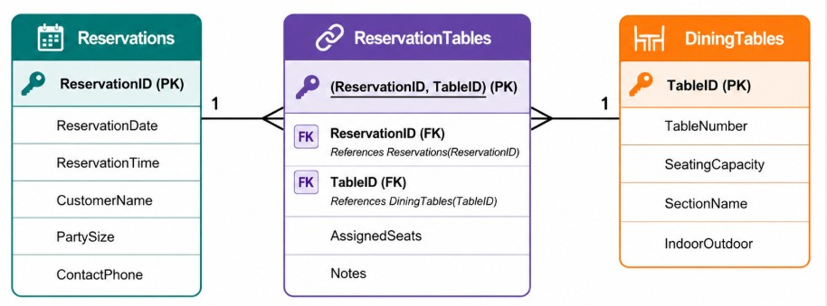
  - Identify the associative entity
    - ReservationTables is the associative entity. It links Reservations and DiningTables
  - Explain why ReservationTables requires a composite primary key
    - ReservationTables requires a composite primary key because each row represents one specific combination of ReservationID and TableID; the composite key (ReservationID, TableID) uniquely identifies each table assigned to a reservation
  - Identify the relationships
    - Reservations has a one-to-many relationship with ReservationTables, DiningTables has a one-to-many relationship with ReservationTables, Reservations and DiningTables have a many-to-many relationship that is resolved by ReservationTables
  - Describe the cardinality between Reservations and DiningTables
    - The cardinality between Reservations and DiningTables is many-to-many: a reservation may use one or more dining tables, and a dining table may be used for many reservations over time
  - Explain how this design prevents duplicate reservations
    - This design prevents duplicate table assignments for the same reservation because the composite primary key (ReservationID, TableID) does not allow the same combination to be entered more than once

